C/C++ PLAYERS ON A TEAM LAB REPORT
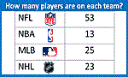
1) Enter your name, student ID, platform (Mac or PC) and date
Name and StudentID: Jay Gupta, Student ID: 0961979
Class: CIS054 C/C++ Programming
Platform (Mac or PC): PC
Date: 2/8/2020

OBJECTIVES:
Use if...else if...else statements to compare numeric values

PROJECT DESCRIPTION:
Design a C or C++ program that does the following: Determine whether a sports team manager needs to add more players to make a full team or cut players from the team if there are too many. The program needs to display the number of additional players needed if there are not enough, or the number of extra players to be eliminated. The program also needs to reject and display an error messages for non-numeric and negative input values.
INPUTS | PROCESSING | OUTPUTS
teamSize  playersOnTeam | Read teamSize from the keyboard  Read playersOnTeam from the keyboard  If playersOnTeam < teamSize Then  Display "There are not enough players" Compute how many more players are needed  Display "# more players are needed"  Else if playersOnTeam > teamSize  Display “There are too many players"  Compute how many more players need to be cut  Display "# players need to be eliminated"  Else  Display “You have the correct number of players” | Number of players needed to be added, removed, or indicate that the number is correct

LAB REPORT:
2) Fill in the TEST VALUES & RESULTS table
Fill in the Test Data Values and Expected Results as shown on the lab assignment from below.
Choose your sport Just Right To Low Too High
Baseball 25 10 27
Football 53 50 57
Basketball 13 11 17
Hockey 23 20 25
Lacrosse 12 11 13
Identify which sport you are choosing.
Fill in the Actual Results after you have run and tested your program
Baseball | TEST DATA VALUES | EXPECTED RESULT  Computed values before the program is run | ACTUAL RESULT  Fill in the output displayed  by the program
Just Right | teamSize = 25, playersOnTeam =25 | The amount of players is just right! | The amount of players is just right!
Too Low | teamSize = 25, playersOnTeam = 10 | There are not enough players.  15 players are needed. | There are not enough players.  15 players are needed.
Too High | teamSize = 25, playersOnTeam = 27 | There are too many players.  2 players need to be cut from the team. | There are too many players.  2 players need to be cut from the team.
Type a negative a number  for the team size | teamSize = -1 | Negative values aren't allowed. | Negative values aren't allowed.
Type letters for number  for the team size | teamSize = Babe Ruth | Illegal entry for team size. | Illegal entry for team size.
Type a negative number  for players on the team | teamSize = 25  playersOnTeam = -7 | Negative values aren't allowed. | Negative values aren't allowed.
Type letters for number  of players on the team | teamSize = 25  playersOnTeam = Yo | Illegal entry for players on the team. | Illegal entry for players on the team.

DISCUSSION:
3) Complete the DISCUSSION section. It does not need to be long, but it needs to be complete.
3a) What did you do to develop the program? ("Followed the Directions" is not a complete description)
I used unit testing; I developed each part of the if/else statement separately, making sure every bit of functionality worked properly. Then, when the code looked complete, I worked to add comments and make readability easier.

3b) What problems did you have and how did you overcome the problems?
I didn’t understand what cin.fail() meant. I looked on the internet, and it said that if the input didn’t match to the declaration’s type (int in this case), it would say true, or false otherwise. That made sense, given the if/else statement.

3c) What happens if you enter a negative number for playersOnTeam?
It states “negative values aren’t allowed”.

PROGRAM OUTPUT:
4) Show seven screen shots of the program execution.
- Too many players on a team
- Not enough players on a team
- The correct number of players on a team
- A negative number entered for the team size
- Letters entered for the team size (example: TWELVE)
- A negative value for the number of players on the team
- Letters entered for the number of players on the team (example: TEN)

IMPORTANT: Capture only the portion of the screen that shows the program output. Do not capture the entire screen even though it may also contain the program output. Many times when I zoom in on the output window, the image resolution is so poor that I am not able to read your output. If this happens, I will ask that you resubmit your lab report.

For the Mac, hold down command + shift keys and press the 4 key to get a screenshot of a selected area of the screen. Use the mouse or touchpad to select the desired area.
Use command+V to paste the clipboard into the lab report.

For Windows, There are two ways you can capture a screen shot of only your program:
- Use Microsoft's Snipping Tool by clicking on the Start icon and selecting "All Programs" then "Accessories". Use the mouse to select the area of the screen you want to save then click Ctrl-C or select the menu items Edit-Copy to save the image to the clipboard.
- Capture the active window to the clipboard by holding down the Alt key and tapping the PrintScreen key. NOTE: some notebook computers require that you hold down a [Fn] key and Alt keys to activate the PrintScreen function. NOTE: Do not click PrintScreen without the Alt key. This would capture the entire screen which would make your program output difficult to see.
Use Ctrl+V to paste the clipboard into the lab report.

Place your seven screenshots here
a)
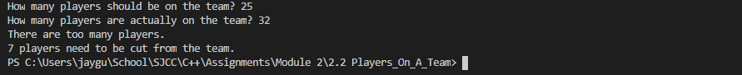

b)
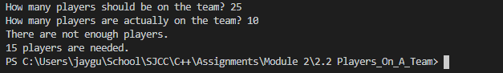

c)
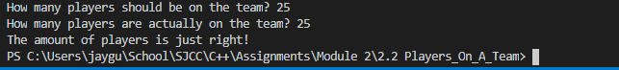

d)

e)

f)
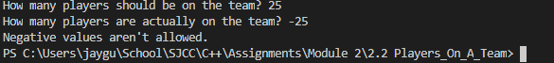

g)
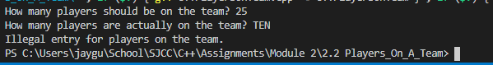

PROGRAM LISTING:
5) Copy and paste the code that YOU typed to make the program work. Your program should include a comment block at the top that shows the name of the program, date and your name. Copy the actual code, not a screenshot of the code.
// C++PlayersOnTeam.cpp
/*
MaxPlayers - this program determines if there are
not enough, too many, or just the right amount of
players on the team
*/
// Jay Gupta
// 2/8/2020
// CIS 054 C/C++ Programming

#include <iostream>
using namespace std;

int main()
{
// declare the variables
int teamSize;
int playersOnTeam;
int morePlayersNeeded;
int playersToBeCut;

// get input; ideal # of players, and how many in reality
cout << "How many players should be on the team? ";
cin >> teamSize;
if (cin.fail()) {
cout << "Illegal entry for team size." << endl;
return 1;
} else if (teamSize < 0) {
cout << "Negative values aren't allowed." << endl;
return 1;
}

cout << "How many players are actually on the team? ";
cin >> playersOnTeam;
if (cin.fail()) {
cout << "Illegal entry for players on the team." << endl;
return 1;
} else if (playersOnTeam < 0) {
cout << "Negative values aren't allowed." << endl;
return 1;
}

// are the # of players less than, greater than, or equal to the ideal?
// compute and display the respective output
if (playersOnTeam < teamSize) {
cout << "There are not enough players." << endl;
morePlayersNeeded = teamSize - playersOnTeam;
cout << morePlayersNeeded << " players are needed." << endl;
} else if (playersOnTeam > teamSize) {
cout << "There are too many players." << endl;
playersToBeCut = playersOnTeam - teamSize;
cout << playersToBeCut << " players need to be cut from the team." << endl;
} else {
cout << "The amount of players is just right!" << endl;
}
return 0;
}

